Nanyang Technological University

**Lab 5 Report:**

**Morphing**

CZ2003 Computer Graphics and Visualization

Student: Trinh Tuan Dung

Matriculation Number: U1720421K

Group: SS1

Seat Number: 28

1. **Display Surface 2 and Surface 3**

|  |  |
| --- | --- |
| Surface | Explanation |
|  | This is the surface defined in the file “surface 2.wrl”.  The parametric functions are:  x=1.5*u*cos(2*pi*v)  y=1.5*u*sin(2*pi*v)*cos(2*pi*v)  z=1.5*u*(sin(2*u*pi))^5  The domain for u and v is [0, 1].  The resolution is [100 100]. |
|  | This is the surface defined in the file “surface 3.wrl”.  The parametric functions are:  x=u*cos(2*pi*v)  y=u*sin(2*pi*v)  z=u*sin(2*u*pi)*sin(2*pi*v)  The domain for u and v is [0, 1].  The resolution is [100 100]. |

1. **Morphing from surface 2 to surface 3**

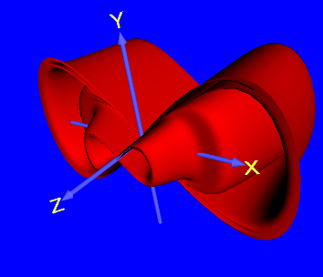 **🡪 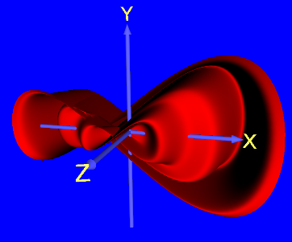 🡪 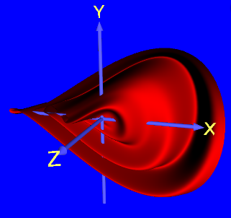 🡪 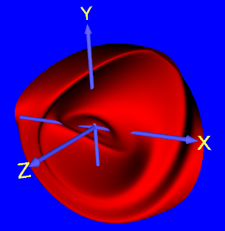🡪** 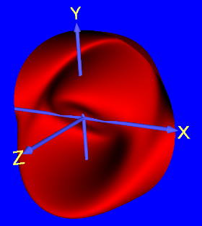

The above 5 pictures are snapshots of the morphing process from surface 2 to surface 3.

This was defined in the file “morphing only.wrl”.

The parametric functions are:

* function for x :

x1 = 1.5*u*cos(2*pi*v);

x2 = u*cos(2*pi*v);

x = x1+(x2-x1)*t

* function for y:

y1 = 1.5*u*sin(2*pi*v)*cos(2*pi*v);

y2 = u*sin(2*pi*v);

y = y1+(y2-y1)*t

* function for z:

z1 = 1.5*u*(sin(2*u*pi))^5;

z2 = u*sin(2*u*pi)*sin(2*pi*v);

z = z1+(z2-z1)*t

The parameter domain for u and v is [0, 1].

The resolution parameter is [100 100].

1. **All together in one file**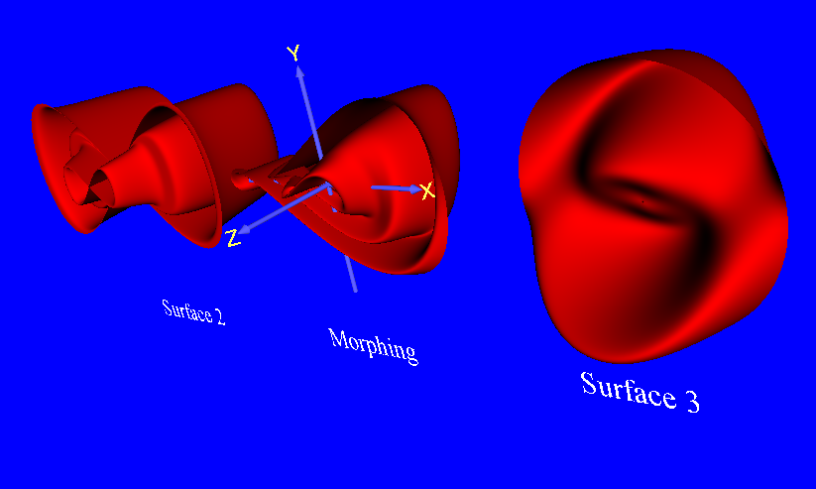

The above picture is a snapshot from the file “morphing from 2 to 3.wrl”.

The left curve is the surface identical to the one defined in “surface 2.wrl”.

The right curve is the surface identical to the one defined in “surface 3.wrl”.

The middle morphing is the morphing from surface 2 to surface 3, identical to the one defined in “morphing only.wrl”.

The domain for u and v is [0, 1].

The resolution parameter is [100 100].